Module:-1
INTRODUCTION TO ANDROID:-
Android is an open source software stack that includes the operating system, middleware, and key applications along with a set of API libraries for writing mobile applications that can shape the look, feel, and function of mobile handsets.
“Android was built from the ground-up to enable developers to create compelling mobile applications that take full advantage of all a handset has to offer. It is built to be truly open. For example, an application could call upon any of the phone's core functionality such as making calls, sending text messages, or using the camera, allowing developers to create richer and more cohesive experiences for users.” This is true, as a developer you can do everything, from sending short messages with just 2 lines of code, up to replacing even the HOME-Screen of your device. One could easily create a fully customized operating system within weeks, providing no more of Google’s default application to the user. “Android is built on the open Linux Kernel. Furthermore, it utilizes a custom virtual machine that has been designed to optimize memory and hardware resources in a mobile environment. Android will be open source; it can be liberally extended to incorporate new cutting edge technologies as they emerge. The platform will continue to evolve as the developer community works together to build innovative mobile applications.”
What It Isn’t
As a disruptive addition to a mature fi eld, it’s not hard to see why there has been some confusion about what exactly Android is. Android is not:
❑ A Java ME implementation Android applications are written using the Java language, but they are not run within a Java ME virtual machine, and Java-compiled classes and executables will not run natively in Android.
❑ Part of the Linux Phone Standards Forum (LiPS) or the Open Mobile Alliance
(OMA) Android runs on an open source Linux kernel, but, while their goals are similar, Android’s complete software stack approach goes further than the focus of these standards defining organizations.
❑ Simply an application layer (like UIQ or S60) While it does include an application layer, “Android” also describes the entire software stack encompassing the underlying operating system, API libraries, and the applications themselves.

❑ A mobile phone handset Android includes a reference design for mobile handset manufacturers, but unlike the iPhone, there is no single “Android Phone.” Instead, Android has been designed to support many alternative hardware devices.

❑ Google’s answer to the iPhone The iPhone is a fully proprietary hardware and software platform released by a single company (Apple), while Android is an open source software stack produced and supported by the Open Handset Alliance and designed to operate on any handset that meets the requirements. There’s been a lot of speculation regarding a Google-branded Android phone, but even should Google produce one, it will be just one company’s hardware implementation of the Android platform.

Android is made up of several necessary and dependent parts including the following:
❑ A hardware reference design that describes the capabilities required of a mobile device in order to support the software stack
❑ A Linux operating system kernel that provides the low-level interface with the hardware, memory management, and process control, all optimized for mobile devices
❑ Open source libraries for application development including SQLite, WebKit, OpenGL, and a media manager
❑ A run time used to execute and host Android applications, including the Dalvik virtual machine and the core libraries that provide Android specific functionality. The run time is designed to be small and efficient for use on mobile devices.
❑ An application framework that agnostically exposes system services to the application layer, including the window manager, content providers, location manager, telephony, and peer-to-peer services
❑ A user interface framework used to host and launch applications
❑ Preinstalled applications shipped as part of the stack
❑ A software development kit used to create applications, including the tools, plug-ins, and Documentation

Android SDK Features
The true appeal of Android as a development environment lies in the APIs it provides.
As an application-neutral platform, Android gives you the opportunity to create applications that are as
much a part of the phone as anything provided out of the box. The following list highlights some of the
most noteworthy Android features:
❑ No licensing, distribution, or development fees
❑ Wi-Fi hardware access
❑ GSM, EDGE, and 3G networks for telephony or data transfer, allowing you to make or receive
calls or SMS messages, or to send and retrieve data across mobile networks
❑ Comprehensive APIs for location-based services such as GPS
❑ Full multimedia hardware control including playback and recording using the camera and
microphone
❑ APIs for accelerometer and compass hardware
❑ IPC message passing
❑ Shared data stores
❑ An integrated open source WebKit-based browser
❑ Full support for applications that integrate Map controls as part of their user interface
❑ Peer-to-peer (P2P) support using Google Talk
❑ Mobile-optimized hardware-accelerated graphics including a path-based 2D graphics library
and support for 3D graphics using OpenGL ES
❑ Media libraries for playing and recording a variety of audio/video or still image formats
❑ An application framework that encourages reuse of application components and the replacement of native applications.

Background Services
Android supports applications and services designed to run invisibly in the background. Modern mobiles are by nature multifunction devices; however, their limited screen size means that generally only one interactive application can be visible at any time. Platforms that don’t support background execution limit the viability of applications that don’t need your constant attention. Background services make it possible to create invisible application components that perform automatic processing without direct user action. Background execution allows your applications to become eventdriven and to support regular updates, which is perfect for monitoring game scores or market prices, generating location-based alerts, or prioritizing and pre-screening incoming calls and SMS messages.

SQLite Database for Data Storage and Retrieval
Rapid and effi cient data storage and retrieval are essential for a device whose storage capacity is limited by its compact nature.
Android provides a lightweight relational database for each application using SQLite. Your applications can take advantage of the managed relational database engine to store data securely and effi ciently. By default, each application database is sandboxed — its content is available only to the application that created it — but Content Providers supply a mechanism for the managed sharing of these application databases.

Shared Data and Interapplication Communication
Android includes three techniques for transmitting information from your applications for use elsewhere:

Notifi cations, Intents, and Content Providers.

Notifi cations are the standard ways in which a mobile device traditionally alerts users. Using the API, you can trigger audible alerts, cause vibration, and fl ash the device’s LED, as well as control status bar

Intents provide a mechanism for message passing within and between applications. Using Intents, you can broadcast a desired action (such as dialing the phone or editing a contact) system-wide for other applications to handle. Intents are an important core component of Android

Content Providers are a way to give managed access to your application’s private database. The data stores for native applications, such as the Contact Manager, are exposed as Content Providers so you can create your own applications that read or modify these data stores.

P2P Services with Google Talk
Based on earlier SDK versions, it’s expected that in later releases you will once again be able to send structured messages from your application to any other Android mobile using Android’s peer-to-peer (P2P) communications service. The Android P2P service uses a specialized version of XMPP (Extensible Messaging and Presence Protocol). Based on Google’s Google Talk instant messaging service, it creates a persistent socket connection between your device and any other online Android handset that ensures communication with low latency and rapid response times.
When made available, you’ll be able to use the Google Talk service for conventional instant messaging, or an interface to send data between application instances on separate devices. This is strong sauce for creating interactive applications that involve multiple users, such as real-time multiplayer games or social applications. The P2P service also offers presence notifi cation, which is used to see if a contact is online. While the P2P service is very attractive in itself, it also plays very well with other Android features. Imagine a background service that transmits locations between friends and a corresponding mapping application that displays these locations or alerts you when friends are nearby. Owing to security concerns, sending data messages with Google Talk isn’t possible in Android 1.0. An instant messaging client is available, and it’s expected that XMPP-compatible IM and data messaging will be made available to developers in a future SDK release.

Extensive Media Support and 2D/3D Graphics
Bigger screens and brighter, higher-resolution displays have helped make mobiles multimedia devices. To make the most of the hardware available, Android provides graphics libraries for 2D canvas drawing and 3D graphics with OpenGL. Android also offers comprehensive libraries for handling still images, video, and audio fi les including the MPEG4, H.264, MP3, AAC, AMR, JPG, PNG, and GIF formats.

Optimized Memory and Process Management
Android’s process and memory management is a little unusual. Like Java and .NET, Android uses its own run time and virtual machine to manage application memory. Unlike either of these frameworks, the Android run time also manages the process lifetimes. Android ensures application responsiveness by stopping and killing processes as necessary to free resources for higher-priority applications. In this context, priority is determined depending on the application with which the user is interacting. Ensuring that your applications are prepared for a swift death but are still able to remain responsive and update or restart in the background if necessary, is an important consideration in an environment that does not allow applications to control their own lifetimes.

2-Setting Up Your Android Development Environment
Android applications, like most mobile phone applications, are developed in a hosttarget development environment. In other words, you develop your application on a host computer (where resources are abundant) and download it to a target mobile phone for testing and ultimate use. Applications can be tested and debugged either on a real Android device or on an emulator. For most developers, using an emulator is easier for initial development and debugging, followed by final testing on real devices. To write your own Android mobile phone applications, you’ll first need to collect the required tools and set up an appropriate development environment on your PC or Mac. In this Topic we’ll collect the tools you need, download them and install them on your computer, and write a sample application that will let you get the feel of writing and running Android applications on an emulator. Linux, Windows, and OS X are all supported development environments, and we’ll show you how to install the latest set
of tools on each. Then, we’ll show you any configuration you need to do after installing the tools (setting PATH environment variables and the like), again for each of the three operating systems. Finally, we’ll write a short little “Hello, Android” application that demonstrates what needs to be done in order to get a generic application running.
The Android SDK supports several different integrated development environments
(IDEs). For this book we will focus on Eclipse because it is the IDE that is best integrated with the SDK, and, hey, it’s free. No matter which operating system you are using, you will need essentially the same set of tools:
• The Eclipse IDE
• Sun’s Java Development Kit (JDK)
• The Android Software Developer’s Kit (SDK)
• The Android Developer Tool (ADT), a special Eclipse plug-in Since you’re probably going to develop on only one of the host operating systems, skip to the appropriate section that pertains to your selected operating system.

Creating an Android Development Environment
The Android Software Development Kit supports Windows (XP and Vista), Linux
(tested on Ubuntu Dapper Drake, but any recent Linux distro should work), and Mac OS X (10.4.8 or later, Intel platform only) as host development environments. Installation of the SDK is substantially the same for any of the operating systems, and most of this description applies equally to all of them. Where the procedure differs, we will clearly tell you what to do for each environment:

1-Install JDK:
The Android SDK requires JDK version 5 or version 6. If you already have one of those installed, skip to the next step. In particular, Mac OS X comes with the JDK version 5 already installed, and many Linux distributions include a JDK. If the JDK is not installed, http://java.sun.com/javase/downloads and you’ll see a list of Java products to download. You want JDK 6 Update n for your operating system, where n is 6 at the time of this writing. Windows (XP and Vista)
• Select the distribution for “Windows Offline Installation, Multi-language.”
• Read, review, and accept Sun’s license for the JDK. (The license has become
very permissive, but if you have a problem with it, alternative free JDKs exist.)
• Once the download is complete, a dialog box will ask you whether you want
to run the downloaded executable. When you select “Run,” the Windows
Installer will start up and lead you through a dialog to install the JDK on
your PC. Linux
• Select the distribution for “Linux self-extracting file.”
• Read, review, and accept Sun’s license for the JDK. (The license has become
very permissive, but if you have a problem with it, alternative free JDKs exist.)
• You will need to download the self-extracting binary to the location in
which you want to install the JDK on your filesystem. If that is a systemwide
directory (such as /usr/local), you will need root access. After the file is downloaded, make it executable (chmod +x jdk-6version-linuxi586. bin), and execute it. It will self-extract to create a tree of directories. Mac OS X Mac OS X comes with JDK version 5 already loaded.

]

Install Eclipse:
The Android SDK requires Eclipse version 3.3 or later. If you do
not have that version of Eclipse installed yet, you will need to go to http://www
.eclipse.org/downloads to get it, and you might as well get version 3.4 (also known
as Ganymede), since that package includes the required plug-ins mentioned in the
next step. You want the version of the Eclipse IDE labeled “Eclipse IDE for Java
Developers,” and obviously you want the version for your operating system. Eclipse will ask you to select a mirror site, and will then start the download.
Windows (XP or Vista) The Eclipse download comes as a big ZIP file that you install by extracting the files to your favorite directory. For this book, we’ll assume that you extracted to C:/eclipse. Eclipse is now installed, but it will not show up in your Start menu of applications. You may want to create a Windows shortcut for C:/eclipse/ eclipse.exe and place it on your desktop, in your Start menu, or someplace else where you can easily find it. Linux and Mac OS X
Note that, as of this writing, the version of Eclipse installed if you request it
on Ubuntu Hardy Heron is 3.2.2, which does not contain all the plug-ins
needed for Android. The Eclipse download comes as a big tarball (.gz file) that
you install by extracting the files to your favorite directory. For this book, we’ll
assume that you extracted to /usr/lib/eclipse. The executable itself is located in
that directory and is named eclipse.

3. Check for required plug-ins:
You can skip this step if you just downloaded a
current version of Eclipse as we recommended. If you are using a preinstalled version of Eclipse, you need to make sure you have the Java Development Tool (JDT) and Web Standard Tools (WST) plug-ins. You can easily check to see whether they are installed by starting Eclipse and selecting menu options “Windows → Preferences...”. The list of preferences should include one for “Java” and one for either “XML” or “Web and XML.” If they aren’t on the list, the easiest thing to do is reinstall Eclipse, as described in the previous step. Installing “Eclipse IDE for Java Developers” will automatically get the needed plug-ins.

4. Install Android SDK:
This is where you should start if you already have the right versions of Eclipse and the JDK loaded. The Android SDK is distributed through Google’s Android site, http://developer.android.com/sdk/1.1_r1/index.html. You will need to read, review, and accept the terms of the license to proceed. When you
get to the list of downloads, you will see a table of distributions. Select the one for
your operating system (XP and Vista use the same distribution). The package (file)
names include the release number. For example, as this is written, the latest
version of the SDK is 1.1_r1, so the filename for Windows is android-sdkwindows- 1.1_r1.zip.

Setting Up
For versions 3.3 and later of Eclipse, the Android download site provides directions about how to install the plug-in through Eclipse’s software updates utility. If you’re using Eclipse 3.2 or the software update technique doesn’t work for you, download the SDK from the Android site and install it using instructions in the next paragraph. The file you download is another archive file, as with Eclipse: a ZIP file on Windows, a tar-zipped file for Linux and MacOS X. Do the same thing as for Eclipse: extract the archive file to a directory where you want to install Android, and make a note of the directory name (you’ll need it in step 6). The extraction will create a directory tree containing a bunch of subdirectories, including one called tools.

5. Update the environment variables:
To make it easier to launch the Android tools, add the tools directory to your path.
• On Windows XP, click on Start, then right-click on My Computer. In the popup
menu, click on Properties. In the resulting System Properties dialog box,
select the Advanced tab. Near the bottom of the Advanced tab is a button, “Environment Variables,” that takes you to an Environment Variables dialog. User
environment variables are listed in the top half of the box, and System environment
variables in the bottom half. Scroll down the list of System environment variables until you find “Path”; select it, and click the “Edit” button. Now you will be in an Edit System Variable dialog that allows you to change the environment variable “Path.” Add the full path of the tools directory to the end of the existing Path variable and click “OK.” You should now see the new version of the variable in the displayed list. Click “OK” and then “OK” again to exit the dialog boxes.
• On Windows Vista, click on the Microsoft “flag” in the lower left of the desktop,
then right-click on Computer. At the top of the resulting display, just below the
menu bar, click on “System Properties.” In the column on the left of the resulting
box, click on “Advanced system settings.” Vista will warn you with a dialog box
that says “Windows needs your permission to continue”; click “Continue.”
Near the bottom of the System Properties box is a button labeled “Environment
Variables” that takes you to an Environment Variables dialog. User environment
variables are listed in the top half of the box, and System environment variables
in the bottom half. Scroll down the list of System environment variables until
you find “Path”; select it, and click the “Edit” button. Now you will be in an
Edit System Variable dialog that allows you to change the environment variable
“Path.” Add the full path of the tools directory to the end of the existing Path
variable, and click “OK.” You should now see the new version of the variable
in the displayed list. Click “OK” and then “OK” again to exit the dialog boxes.
• On Linux, the PATH environment variable can be defined in your ~/.bashrc
~/.bash_profile file. If you have either of those files, use a text editor such as
gedit, vi, or Emacs to open the file and look for a line that exports the PATH
variable. If you find such a line, edit it to add the full path of the tools directory
to the path. If there is no such line, you can add a line like this:
export PATH=${PATH}:your_sdk_dir/tools where you put the full path in place of your_sdk_dir.
• On Mac OS X, look for a file named .bash_profile in your home directory (note
the initial dot in the filename). If there is one, use an editor to open the file and
look for a line that exports the PATH variable. If you find such a line, edit it to
add the full path of the tools directory to the path. If there is no such line, you
can add a line like this: export PATH=${PATH}:your_sdk_dir/tools where you put the full path in place of your_sdk_dir.

6. Install the Android plug-in (ADT):
Throughout this book, we will make use of the Android Development Tool plug-in that Google supplies for use in building Android applications. The plug-in is installed in much the same way as any other Eclipse plug-in:
a. Start Eclipse, if it’s not already running.
b. From the menu bar, select “Help → Software Updates → Find and Install...”.
c. In the Install/Update dialog, select “Search for new features to install” and
click on “Next.”
d. In the Install dialog, click on “New Remote Site.” A “New Update Site” dialog
pops up. Enter a name for the plug-in (“Android Plugin” will do), and the URL
for updates: https://dl-ssl.google.com/android/eclipse. Click “OK.”
e. The new site should now appear in the list of sites on the Install dialog. Click
“Finish.”
f. In the Search Results dialog, select the checkbox for “Android Plugin →
Developer Tools” and click “Next.”
g. The license agreement for the plug-in appears. Read it, and if you agree, select
“Accept terms of the license agreement” and click “Next.” Click “Finish.”
h. You will get a warning that the plug-in is not signed. Choose to install it anyway
by clicking “Install All.”
i. Restart Eclipse.
j. After Eclipse restarts, you need to tell it where the SDK is located. From the
menu bar, select “Window → Preferences.” In the Preferences dialog, select
“Android” in the left column.
k. Use the “Browse” button to navigate to the place you installed the Android
SDK, and click on “Apply,” then on “OK.”

Congratulations—you have installed a complete Android development environment without spending a penny. As you’ll see in this and subsequent chapters, the environment includes a very sophisticated set of tools to make Android programming easier, including:
• An Integrated Development Environment based on Eclipse, arguably the premier
IDE for Java development. Eclipse itself brings many valuable development features. Google and OHA have taken advantage of Eclipse’s extensibility to provide features customized for Android, including debugging capabilities that are tuned to the needs of mobile application developers like you.
• A Java development environment and Dalvik virtual machine that build on Sun’s
JDK foundation to provide a very sophisticated programming environment for
your applications.
• A complete mobile phone emulator that allows you to test your applications without having to download them to a target mobile phone. The emulator includes
features for testing your application under different mobile phone communication conditions (fading, dropped connections, etc.).
• Test tools, such as Traceview, which allow you to tune your application to take best advantage of The limited resources available on the moblie phone.

3. Writing Your First Android Application
Starting a New Android Project
To create a new Android project using the Android New Project Wizard, do the following:
1. Select File ➪ New ➪ Project.
2. Select the Android Project application type from the Android folder and click
Next.
3. In the dialog that appears (shown in Figure 2-4), enter the details for your new project. The ‘‘Project name’’ is the name of your project file; the ‘‘Package name’’ specifies its java package;
Create Activity lets you specify the name of a class that will be your initial Activity; and the ‘‘Application name’’ is the friendly name for your application. ‘‘Min SDK Version’’ lets you specify the minimum version of the SDK that your application will run on.
Selecting the minimum SDK version requires you to choose between gaining
functionality provided in newer SDK releases and making your application
available to a larger group of Android devices. Your application will be available
from the Google Android Market on any device running the specified build or
higher.
Android version 1.6 (Donut) is version 4 — at the time of going to print, the
majority of Android devices were currently running at least version 4. The 2.0
(Eclair) SDK is version 5, while 2.1 is version 7
4. When you’ve entered the details, click Finish.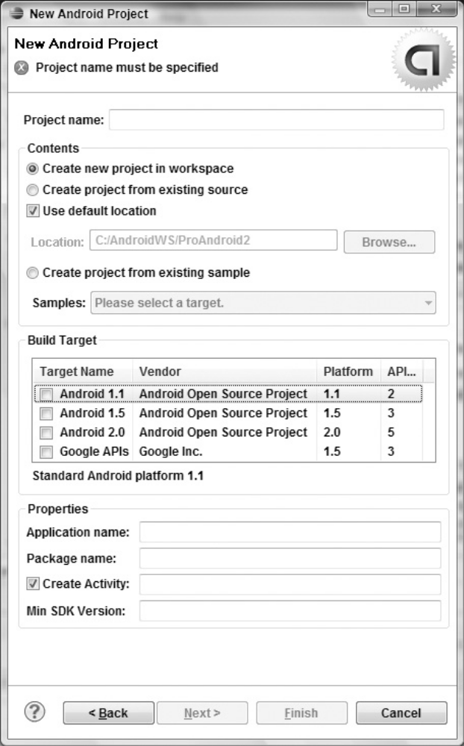|

If you selected Create Activity the ADT plug-in will create a new project that includes a class that
extends Activity. Rather than being completely empty, the default template implements Hello World. Before modifying the project, take this opportunity to configure launch configurations for running and debugging.

Creating a Launch Configuration
Launch configurations let you specify runtime options for running and debugging applications. Using a launch configuration you can specify the following:
➤ The Project and Activity to launch
➤ The virtual device and emulator options to use
➤ Input/output settings (including console defaults)
You can specify different launch configurations for running and debugging applications. The following steps show how to create a launch configuration
for an Android application:
1. Select Run Configurations. . . or Debug Configurations. . . from the Run menu.
2. Right-click Android Application on the project type list, and select New.
3. Enter a name for the configuration. You can create multiple configurations for each project, so create a descriptive title that will help you identify this particular setup.
4. Now choose your start-up options. The first (Android) tab lets you select the project to run and the Activity that you want to start when you run (or debug) the application. Figure 2-5 shows the settings for the project you created earlier.
5. Use the Target tab shown in Figure 2-6 to select the default virtual device to launch on, or select manual to select a device or AVD each time. You can also configure the emulator’s network connection settings and optionally wipe the user data and disable the boot animation when launching a virtual device. Using the command line textbox you can specify additional emulator start-up options if needed.
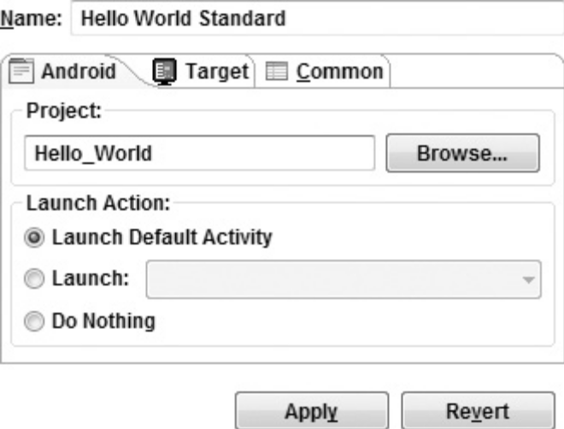

6. Finally, set any additional properties in the Common tab.
7. Click Apply, and your launch configuration will be saved.
Running and Debugging Your Android Applications
You’ve created your first project and created the run and debug configurations for it. Before making any changes, test your installation and configurations by running and debugging the Hello World project. From the Run menu select Run or Debug to launch the most recently selected configuration, or select Run Configurations. . . or Debug Configurations. . . to select a specific configuration to use.
If you’re using the ADT plug-in, running or debugging your application does the following:
➤ Compiles the current project and converts it to an Android executable (.dex)
➤ Packages the executable and external resources into an Android package (.apk)
➤ Starts the selected virtual device (if you’ve selected an AVD and it’s not already running)
➤ Installs your application onto the target device
➤ Starts your application
If you’re debugging, the Eclipse debugger will then be attached, allowing you to set breakpoints and debug your code. If everything is working correctly you’ll see a new Activity running in the emulator in figure.

Understanding Hello World Let’s take a step back and have a real look at your first Android application. Activity is the base class for the visual, interactive components of your application; it is roughly equivalent to a Form in traditional desktop development. Listing 2-1 shows the skeleton code for an Activity-based class; note that it extends Activity, overriding the onCreate method.

package com.paad.helloworld;
import android.app.Activity;
import android.os.Bundle;
public class HelloWorld extends Activity {
/** Called when the activity is first created. */
@Override
public void onCreate(Bundle savedInstanceState) {
super.onCreate(savedInstanceState);
}
}

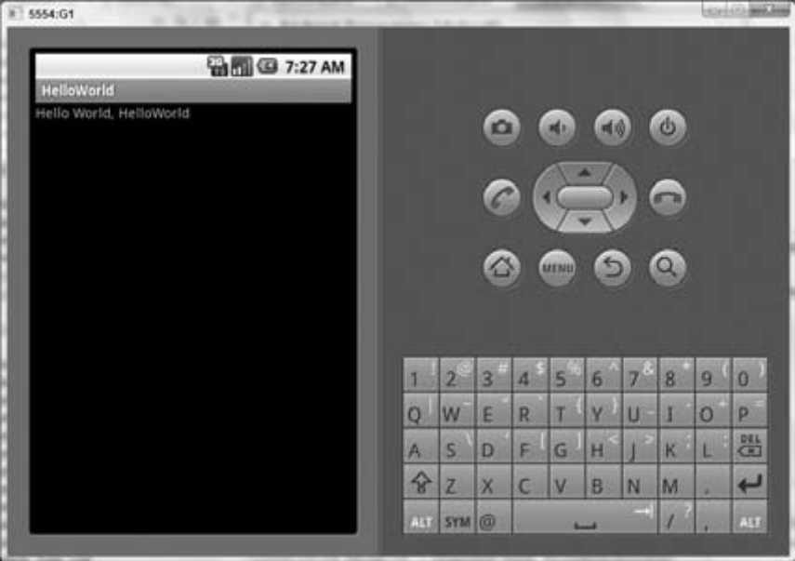

What’s missing from this template is the layout of the visual interface. In Android, visual components are called Views, which are similar to controls in traditional desktop development.
The Hello World template created by the wizard overrides the onCreate method to call setContentView, which lays out the user interface by inflating a layout resource, as highlighted below:

@Override
public void onCreate(Bundle savedInstanceState) {
super.onCreate(savedInstanceState);
setContentView(R.layout.main);
}

The resources for an Android project are stored in the res folder of your project hierarchy, which includes drawable, layout, and values subfolders. The ADT plug-in interprets these resources to provide design-time access to them through the R variable, as described in Chapter 3

<?xml version="1.0" encoding="utf-8"?>
<LinearLayout xmlns:android="http://schemas.android.com/apk/res/android"
android:orientation="vertical"
android:layout_width="fill_parent"
android:layout_height="fill_parent">
<TextView
android:layout_width="fill_parent"
android:layout_height="wrap_content"
android:text="Hello World, HelloWorld"
/>
</LinearLayout>
Defining your UI in XML and inflating it is the preferred way of implementing your user interfaces, as it neatly decouples your application logic from your UI design. To get access to your UI elements in code, you add identifier attributes to them in the XML definition. You can then use the findViewById method to return a reference to each named item. The following XML snippet shows an ID attribute added to the Text View widget in the Hello World template:

<TextView
android:id="@+id/myTextView"
android:layout_width="fill_parent"
android:layout_height="wrap_content"
android:text="Hello World, HelloWorld"
/>
And the following snippet shows how to get access to it in code:
TextView myTextView = (TextView)findViewById(R.id.myTextView);
Alternatively (although it’s not generally considered good practice), you can create your layout directly in code, as shown in Listing 2-3

public void onCreate(Bundle savedInstanceState) {
super.onCreate(savedInstanceState);
LinearLayout.LayoutParams lp;
lp = new LinearLayout.LayoutParams(LayoutParams.FILL_PARENT,
LayoutParams.FILL_PARENT);
LinearLayout.LayoutParams textViewLP;
textViewLP = new LinearLayout.LayoutParams(LayoutParams.FILL_PARENT,
LayoutParams.WRAP_CONTENT);
LinearLayout ll = new LinearLayout(this);
ll.setOrientation(LinearLayout.VERTICAL);
TextView myTextView = new TextView(this);
myTextView.setText("Hello World, HelloWorld");
ll.addView(myTextView, textViewLP);
this.addContentView(ll, lp);
}
All the properties available in code can be set with attributes in the XML layout. As well as allowing easier substitution of layout designs and individual UI elements, keeping the visual design decoupled from the application code helps keep the code more concise.

